Lecture 2: Volume of Distribution
- Amount/Drug(mg), concentration(mg/L, mM)
- Volume is simply a mathematical term relating an amount to a concentration
- Plasma drug concentration
- 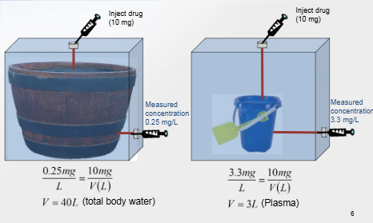
- Apparent Volume
- 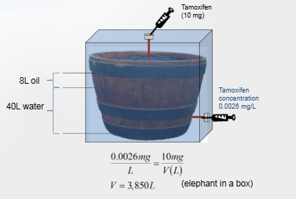
- We check concentration from plasma so other could have gone to tissues. We can understand that way.
- Generally, V does not correspond to a physiological volume.
- From reading V, we are able to
** affinity : similarity, connection

Two-Compartment model
- In 2C model, distribution phase is slow and can be observed kinetically
- In 1C model, distribution is assumed to occur so quickly that it is not observed
- 